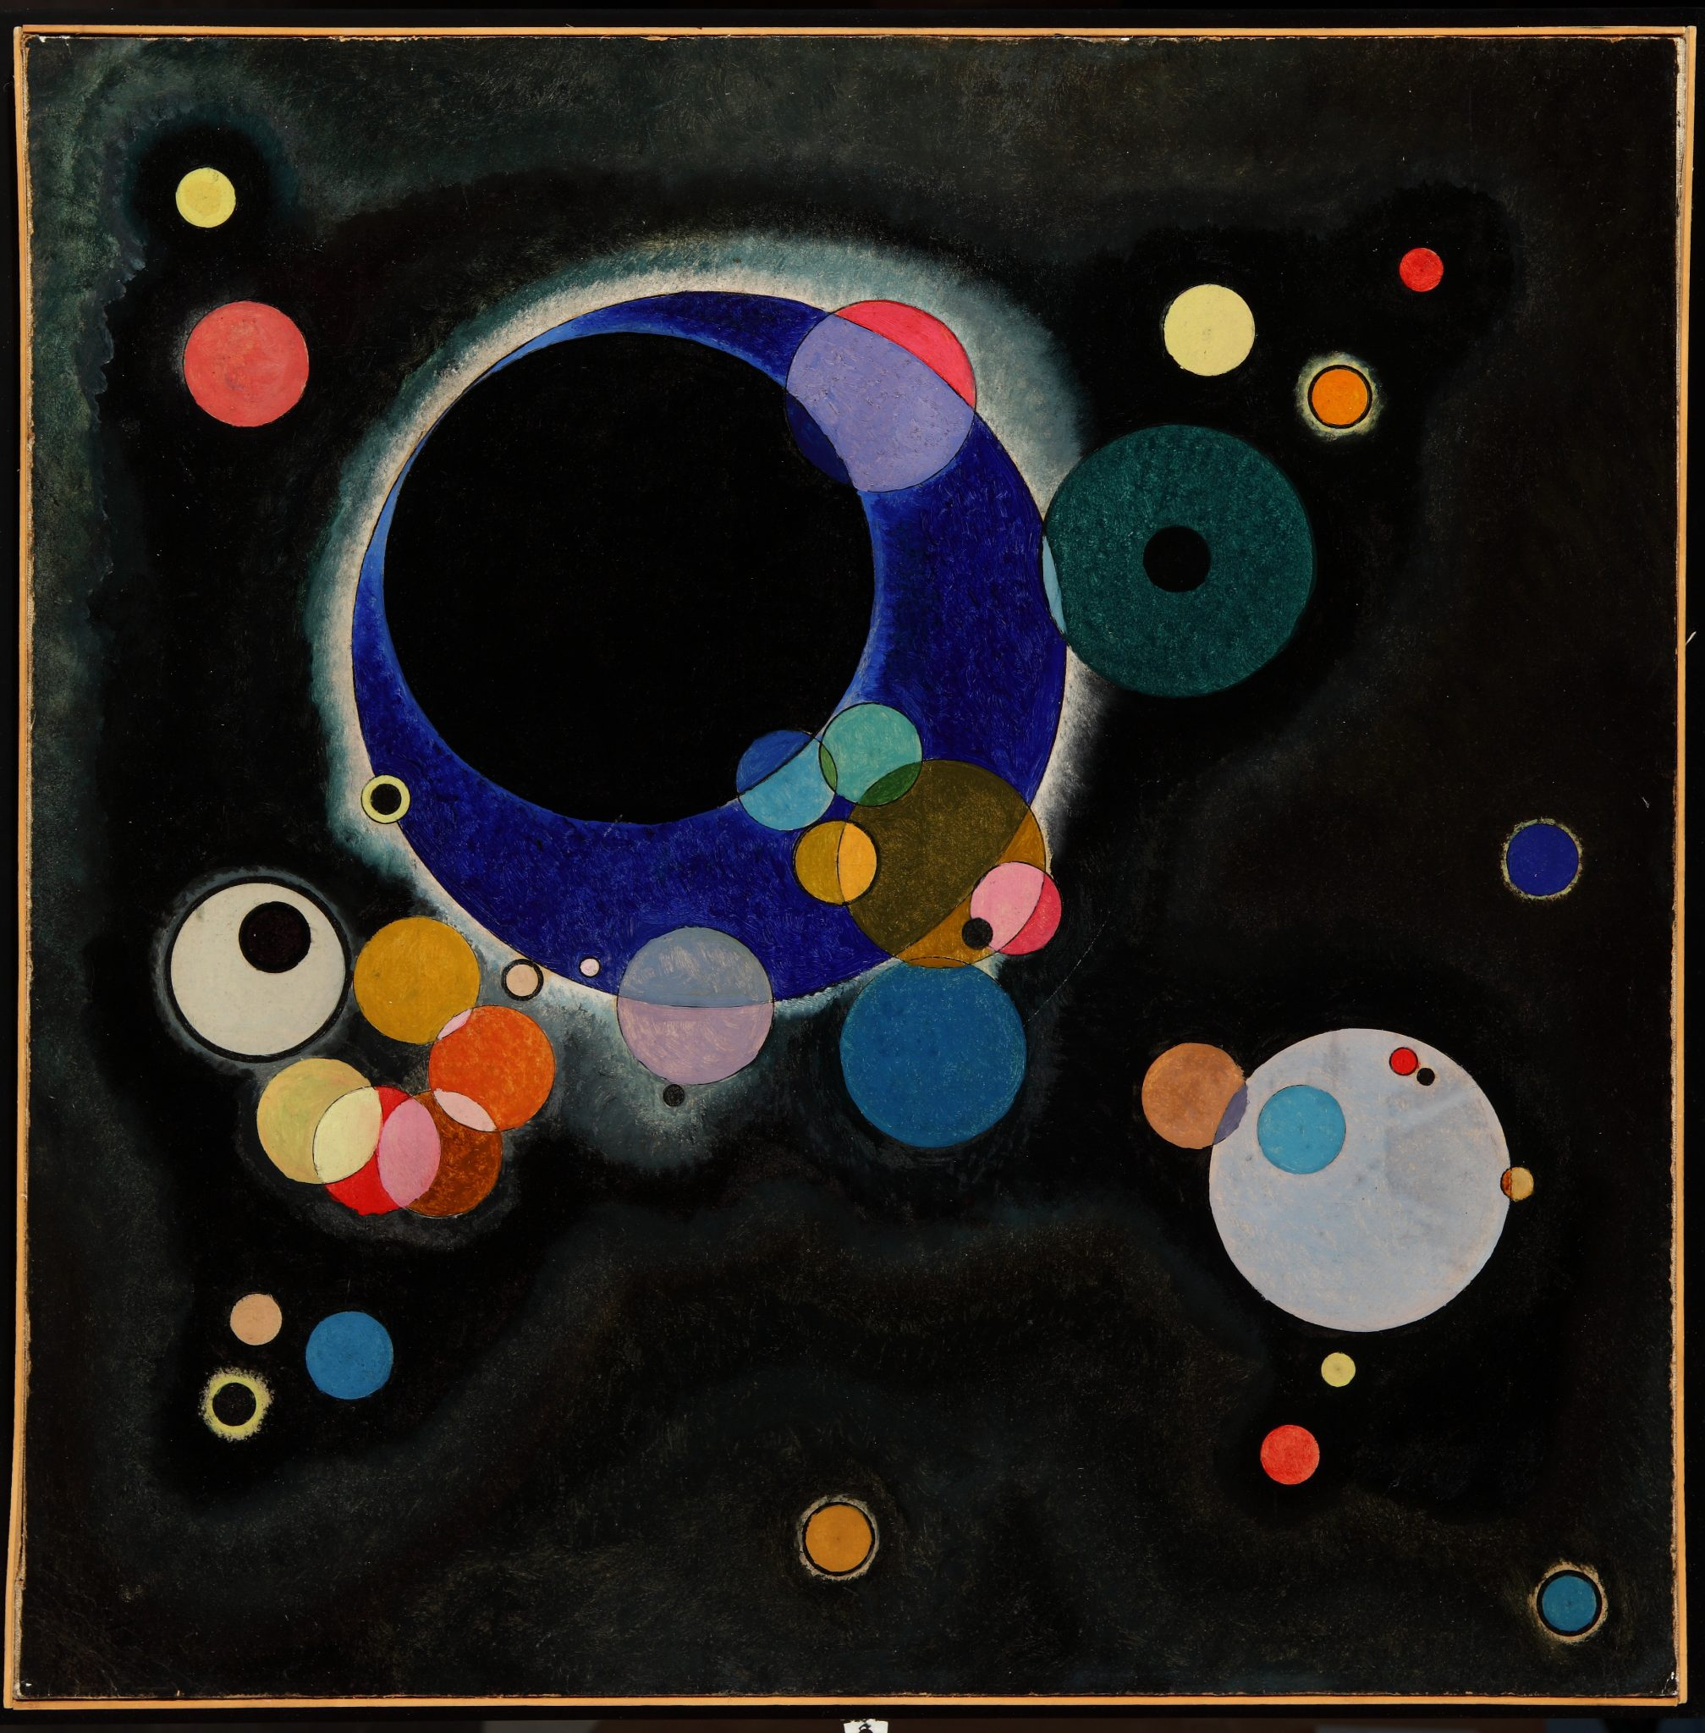

This one’s a comparatively easy one. Let me observe the things I note:

* Circles, obviously.
* Many circles are made in relation to other circles, sometimes intersecting, and sometimes inhabiting the interior completely (some centered, others not).
* Many also have “auras” around them, which resemble brushstrokes or splashes of light.
* There are also gradients having an influence on elements, although these gradients do not always appear. They’re most pronounced with the primary background.
* It’s almost akin to a gravitational effect, only it’s akin to a gravity of attention.

First Step: Put a Circle on a Screen, have it vary in size and position. It must not overlap with the border.

Second Step: Many of these colors aren’t pure. They have texture.

Here’s a comparison of texture at several different levels of variance (RGB value is 125, 125, 125)

|  |  |  |
| --- | --- | --- |
| 5 | 10 | 20 |
|  |  |  |

I feel like 10 creates the proper balance I’m looking for.

Colors I especially like the look of:

* 48,122,88
* 164, 1, 192
* 94, 141, 89
* 132, 63, 131
* 5, 41, 114
* 13, 71, 21
* 171, 145, 195
* 9, 191, 13
* 171, 231, 161
* 113, 160, 17

I feel like adding some amount of variance makes the colors gentler.

For now, textures have been a big headache, possibly due to attempting them in Java rather than Processing natively. For now, I’m putting this to the side.

I didn’t intend to have an aura here inside the intersection, but I actually like how it looks in terms of adding a subtle transition and noise. Bear that in mind. This happened because the first circle placed its aura, and then the second circle was formed and LERPed partly over that aura.

I could avoid that by recording the position and radius of all circles and only adding the radius after they’ve been made, but the question is – do I?

Starting to look better. One problems is that the aura is the same for every radius, which doesn’t make a lot of sense. Let’s see if we can fix that.

I may want to add a recursion decay component.

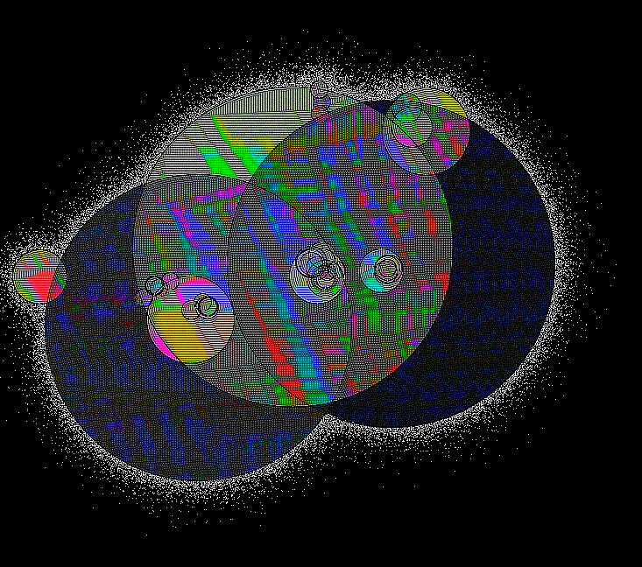

Well this is a happy accident! I didn’t expect this, but it happened due to the particular pattern of my convolution network.

float[][] matrix = {   
 { -1, -1, -1 },  
 { -1, 9, -1 },  
 { -1, -1, -1 } };

This is a high pass filter!